**（Screenshot presentation of GitHub.）**

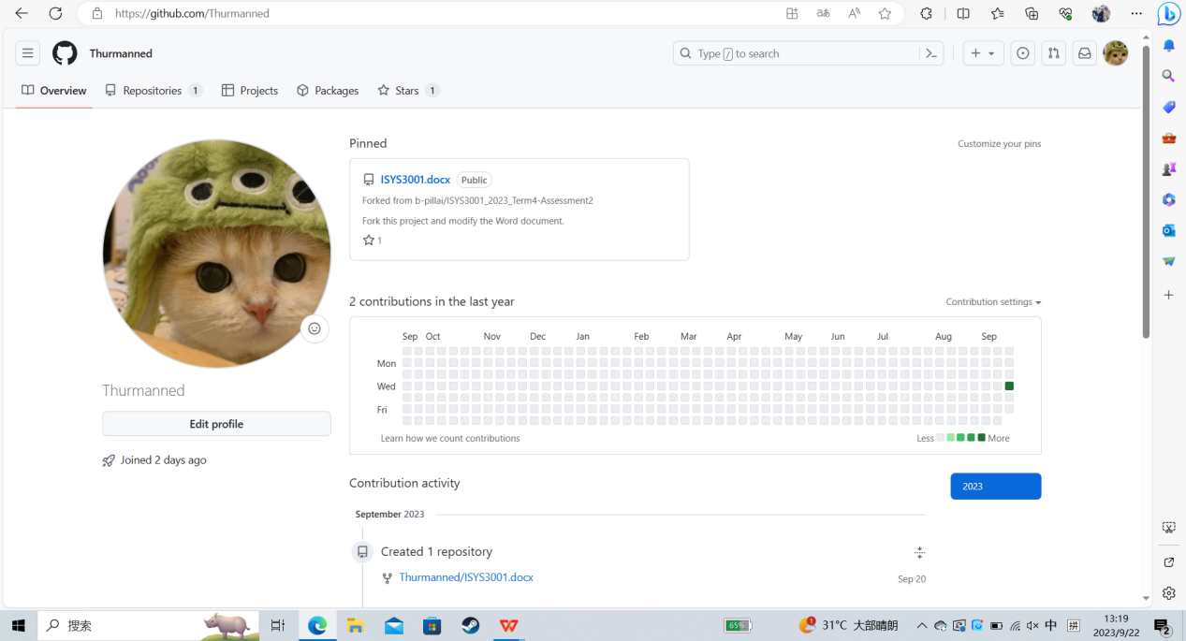

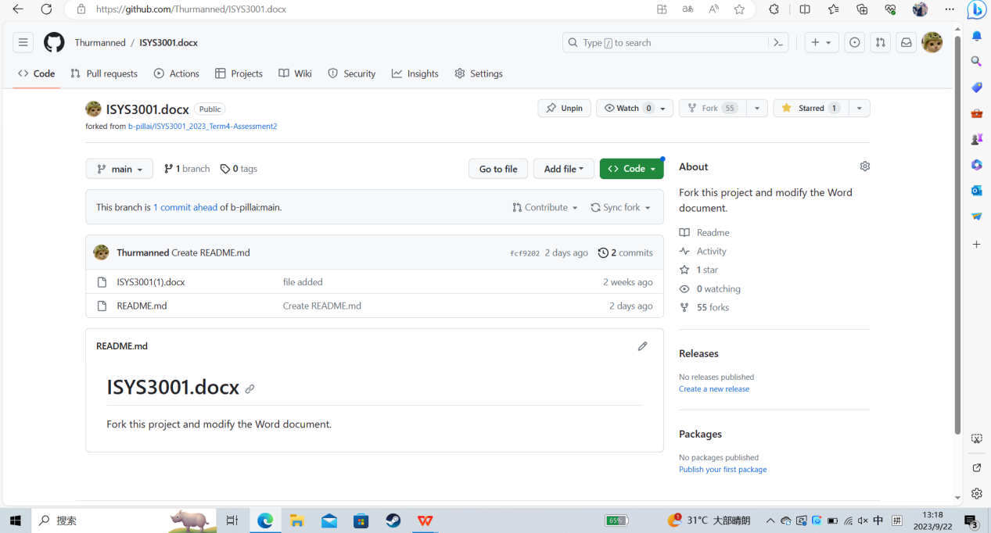

**Configuration Management**

To simplify the software development process and reduce conflicts and errors, companies should consider implementing the following actions:

1.Change management：

The person in charge of the change shall fully communicate with the relevant personnel, including the change purpose, scope, change plan, change plan, control measures, personnel training, resource input, etc. In the process of implementation, special personnel should be assigned to implement, supervise and inspect, and verify regularly to ensure that the requirements of the plan are met. In case of deviation of the change plan, cause analysis and reevaluation shall be done in time, and the method and control plan shall be adjusted after approval by relevant personnel. In each link, the responsible person is responsible for the operation process, operation methods and operating conditions, so as to standardize them.

2.Version management：

The naming of the versions should be normative, Effectively manage code and track changes, The software version number consists of four parts, The first 1 is the master version number, The second 1 is the subversion number, The third number of 1 is the phase version number, The fourth part is divided into date version number and Greek letter version number, There are five Greek letter version numbers, The following values are: base, alpha, beta, RC, release. This enables managers and developers to repair bugs more effectively and overhaul product quality, Different main version models shall be responsible by the corresponding department for research and development and future repair and version iteration, Minimize conflict and provide reliable records of historical modifications, Pathway and hierarchy-based design, versioning allows for easier collaboration, Simplified code consolidation, And help to return to steady state when needed.

3.System building：

Create an automated and repairable system, such as continuous integration, project integration management is the first project management knowledge area, mainly involves ensuring the different tasks of the project, the purpose of continuous integration is to avoid integration problems, in extreme programming methodology, continuous integration needs to achieve the best results, must rely on automated integration unit testing and test driven development. First, you must assume that all unit tests have been completed and passed in the development environment before the online operation. This will help avoid one developer's job process, disrupting other developers' jobs. If necessary, you can use partially completed functions, such as using function switching. Thus allowing developers to address these issues in time. Systems approaches like continuous integration allow early detection of conflict and facilitate ongoing collaboration throughout the development life cycle.

4.Release management：

The purpose of publishing management practices is to provide new and changed services and features for (end users) use. Establish a SOP-structured release management process to ensure a smooth and consistent deployment. In the actual work we may also encounter for software integration, deployment, release, delivery, online terms, as for their dependence, namely who first, in addition to integration is the first to complete, several other activities without fixed dependence, their sequence needs according to the specific application scenarios, release management can be used as changes in the implementation of the process. At this point, the main purpose of release management is to ensure that the content of the planned change (usually the software) is available to the end user. Continuous delivery and deployment practices, such as continuous deployment (continuous deployment, CD), can help to automate the release process and reduce the risk of deployment errors.

**Request for Proposal (RFP)**

###### Title: Integrated System for Aussie Business Buzz (ABB)

1.Introduction:

Aussie Business Buzz (ABB) is a technology product retailer and repair service provider with multiple branch shops. ABB is seeking an integrated system to support their operations, including customer relations management, purchase history tracking, and device repair management. This Request for Proposal (RFP) aims to solicit proposals from vendors capable of delivering a robust and scalable system to meet ABB's initial requirements and future expansion plans.

2. Task object

Our goal is to create an automated and self-healing integrated system for ABB to support the operations of four subsidiaries, which will include the following content：

**A) Establish a customer relationship database**

* Maintain and store customer information
* Save the order record and the historical information
* Store the maintenance records and provide the after-sales service

1. **Complete digital marketing system**

* E-mail
* social media
* The influence means of modern technology

**C) Track the order information**

* Order information and service records for the product
* Use modern technology to integrate relevant data on customer relationships

**D) Maintenance and management of the equipment**

* Track device health information
* Handle sold products and repair parts

**E）Integrate the inventory management system**

* Warehouse and exit management fill in entry and exit information online, the system automatically code
* Inventory allocation

1. **Monitoring management system**

* Information on supervising inventory, employees, and orders
* Provide more comprehensive reporting to management
* Put forward reasonable suggestions for task allocation and staffing

The system has strong flexibility and high fault tolerance, which can help ABB expand in other fields in the future. It should ensure efficient operations and data consistency across branches, and seamless integration is a good choice.

3.Job content:

**（The proposed integrated system shall include the following components and functions）**

**a)Customer relationship database:**

* Keep any customer information, store order information and order records
* Create a retrieval system to facilitate marketing and customer information management
* Allows employees to group customers and add labels
* Maintain a comprehensive customer purchase history, including the products and services purchased, transaction dates, and amounts

**b)Marketing system:**

* Work with other brands to cross over customer resources and use social consolidation marketing technology
* Support for email, social media and many other modern marketing technologies
* Take a performance approach, using the customer relationship database for digital marketing
* Marketing systems should be able to capture prospect details from the website.

**c) Inventory management system:**

* Mark on each product and part and the repaired parts
* Custom machining parts as required
* Allows status updates to be recorded throughout the maintenance process
* Assign a unique identifier to each service request for efficient tracking

**d) Managerial reports :**

* Generate a comprehensive evaluation report through the CRlibrary
* Through the AI big language model to deeply analyze and interpret the company's operating status
* Managers can visit within the company from anywhere
* Real-time update of customer information status, inventory order information

***Ask:***

***Interested suppliers should submit proposals to address the following issues:***

1. **Supplier background and experience:**

* Discuss the supplier's experience and cognitive system in the integrated system
* List the outstanding achievements and cooperation in the past decade background

**b) Recommended solution:**

* Provide the solution plan book, including the system development and the software promotion
* Simulate the working scenario, calculate the market share ratio, and evaluate the feasibility

**The proposed system shall meet the following technical requirements:**

1. Accessibility: The system shall be accessible at all ABB branches, allowing the authorized users to safely access and modify the relevant data.
2. Scalability: The system shall be designed to accommodate the ABB expansion plan to support additional branches without compromising performance or data integrity.
3. Data security: The system shall ensure the privacy and security of customer information, and adopt appropriate data encryption and access control measures.
4. Integration: The system shall support seamless integration between various modules to achieve real-time data synchronization and consistent reporting.
5. User-friendly interface: The system shall have an intuitive and user-friendly interface to enable ABB staff to easily navigate and utilize its functions.

**c) Implementation plans：**

* Assess human resources, resources and other budgets
* Detailed management, SOP pipeline operation

**d) Price**

* Provide detailed expense instructions, including software development, licensing, project description, and system maintenance
* Extra cost

**Response Submissions:**

Interested suppliers should submit their proposals to [1356******@qq.com] in an electronic format (PDF), no later than [25 / 9 / 2023]. Late delivery of the materials may not be considered.

**Assessment criteria:**

The review will be conducted according to the following guidelines:

1. Meet the requirements and objectives of ABB.
2. the technical feasibility and scalability of the proposed solution.
3. supplier expertise, experience, and recommendations.

D) Price competitiveness and value for money.

**Timeline:**

A) RFP release date: [16 / 9 / 2023]

B) Proposal submission deadline: [25 / 9 / 2023]

C) Supplier selection and notification: [25 / 9 / 2023]

D) Project startup: [4 / 9 / 2023]

**Please note: ABB reserves the right to accept or reject any proposal, make inquiries or clarification, and modify the option**